3.4 Climate

3.4.1: Climatic conditions at Picard Station:

Manual temperature and rainfall readings have been taken regularly at the station in 2005 (Table 1).

Table 1: Monthly meteorological data from Picard station for 2005

 | Jan | Feb | Mar | Apr | May | Jun | Jul | Aug | Sep | Oct | Nov | Dec
Mean dry bulb, Cº | 28.44 | 28.26 | 27.98 | 28.35 | 27.33 | 25.62 | 24.60 | 24.27 | 24.74 | 26.13 | 27.32 | 27.9
Mean wet bulb,Cº | 27.84 | 27.89 | 27.89 | 27.98 | 27.18 | 25.51 | 24.38 | 24.40 | 24.46 | 25.26 | 26.41 | 26.9
Mean Max ,Cº | 33.60 | 33.55 | 33.84 | 34.02 | 33.97 | 34.00 | 34.00 | 28.26 | 28.56 | 29.37 | 31.31 | 32.3
Mean Min ,Cº | x | x | x | x | x | x | x | x | 23.12 | 24.17 | 24.47 | 25.3
Wind mean | x | x | x | x | x | x | x | x | x | x | x | X
Wind max | x | x | x | x | x | x | x | x | x | x | x | X
Rainfall (mm) | 249.3 | 152.85 | 150.95 | 170.6 | 179.05 | 9.33 | 38.28 | 17.58 | 4.1 | 5 | 25.55 | 77.8

A) Temperature

In 2005, highest temperatures were found at the beginning and the end of the year, with temperatures close to 29 Cº at the beginning and 28 Cº at the end (Figure 1). Generally 2005 is showing the same seasonality pattern as for the period 2000-2004 (Figure 2). Indeed, the first months of the years, temperatures decrease gradually to a minimum close to 24 Cº in July and August, then returning to highest at the end of the year. Some years, the decrease of temperature occurs later, for example in 2005, the first 4 months were at similar temperature. In December 2005 the value remained a bit lower than usual not reaching 28 Cº.

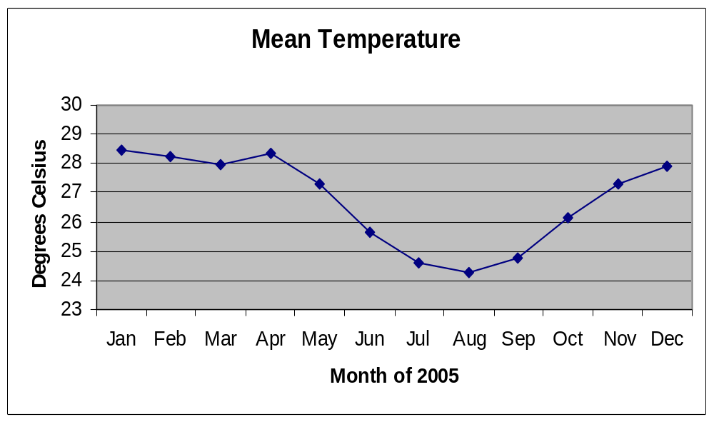
Figure 1: Mean dry bulb temperature at the station in 2005
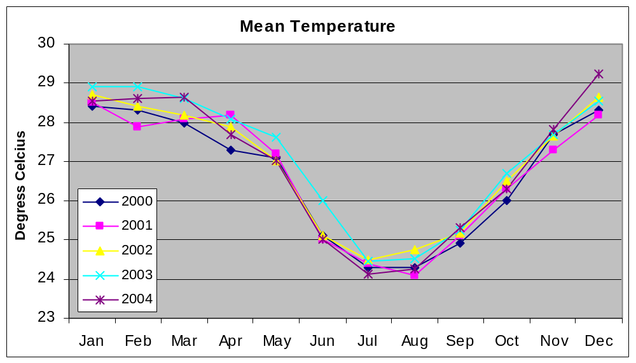
Figure 2: Mean dry bulb temperature between 2000 and 2004

B) Rain fall at Picard station

Rainfall in 2005 (Figure 3) was maximum at the beginning of the year in January, reaching 250 mm. From February to May, in 2005, we observed values close to 150 mm per month. From June a sharp decreased occurred to values situated below 50 mm until November. It is in December that the precipitation increased above the 50 mm reaching 77.8 mm, tripling the amount observed in November.

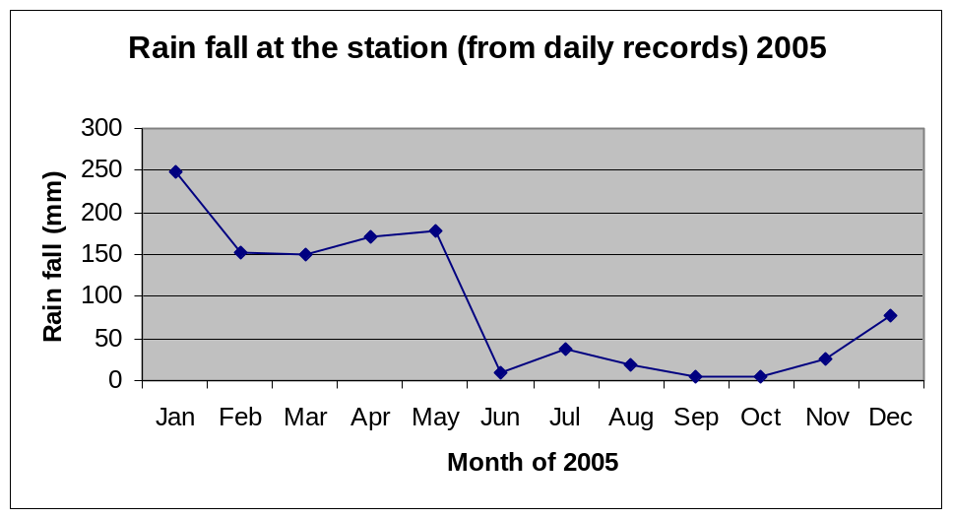
Figure 3: Rainfall at the station for 2005

Generally speaking this is the pattern we observed in most years; however from a year to another, variations can occur. January is not always with the maximum it can often be February and December can reach higher values than in 2005. also show the same rain variation pattern as over the period 2000-2004, have shown typical patterns (Figure 4.2).

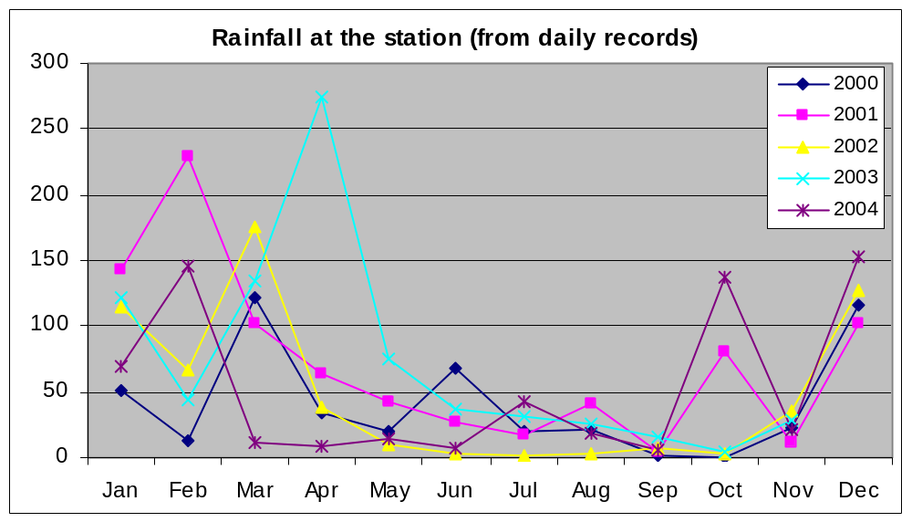

Figure 4: Rainfall at the station between 2000 and 2004

3.4.2: Climatic conditions at outstations on Aldabra:

- Rain fall at outstations

At outstations on Aldabra monthly rain fall is collected (Table 2).

Table 2: Monthly rain fall (mm) per outstation location and total annual rain fall from rain gauges set around Aldabra Island in 2005.
Location | Jan | Feb | Mar | Apr | May | June | July | Aug | Sep | Oct | Nov | Dec | Total*
Cinq Cases Hut | 265 | 320 | 270 | 8 | 184 | 7 | 50 | 3 | 14 | 2 | 7 | 5 | 1278
Cinq Cases Groves | 236 | 330 | 185 | 10 | 195 | 10 | 43 | 5 | 20 | 5 | 10 | 10 | 1221
Dune Jean Louis | 245 | 280 | 155 | 50 | 118 | 31 | 68 | 8 | 14 | 10 | 0 | 40 | 1190
Dune D'Messe | 225 | 295 | 210 | 67 | 180 | 28 | 70 | 10 | 9 | 5 | 0.5 | 75 | 1174.5
Anse Mais | 310 | 90 | 35 | 145 | 292 | 48 | 37 | 25 | 12 | 4 | 10 | 60 | 1135
Anse Var | 112 | 395 | 104 | 60 | 119 | 35 | 20 | 0 | 10 | 0 | 2 | 1 | 1068
Bassin Lebine | 250 | 274 | 170 | 95 | 202 | 51 | 33 | 7 | 13 | 5 | 30 | 60 | 1059
Gionnet | 333 | 280 | 45 | 360 | 67 | 43 | 60 | 18 | 16* | 14 | 5 | 53 | 1046
Polymnie | 140 | 270 | 192 | 226 | 63 | 30 | 42 | 18 | 14* | 10 | 10 | 45 | 1021
Anse Malabar | 450 | 120 | 95 | 155 | 175 | 85 | 31 | 38 | 27 | 20 | 22.5* | 25 | 1019
Middle Camp | 355 | 127 | 110 | 85 | 160 | 45 | 30 | 20 | 17 | 12 | 10 | 50 | 987.5
Ile Esprit | 285 | 100 | 190 | 71 | 257 | 20 | 25 | 5 | 5 | 4 | 0 | 25.5 | 858
Average all locations | 267 | 240 | 147 | 111 | 168 | 36 | 42 | 13 | 14 | 8 | 8 | 37 | 1088.1
* Total annual precipitation per location

The total rain fall, for all outstations combined, is following the same general seasonal pattern as the one observed at Picard station. Maximum is situated in January with low values observed from June to November (Figure 5).

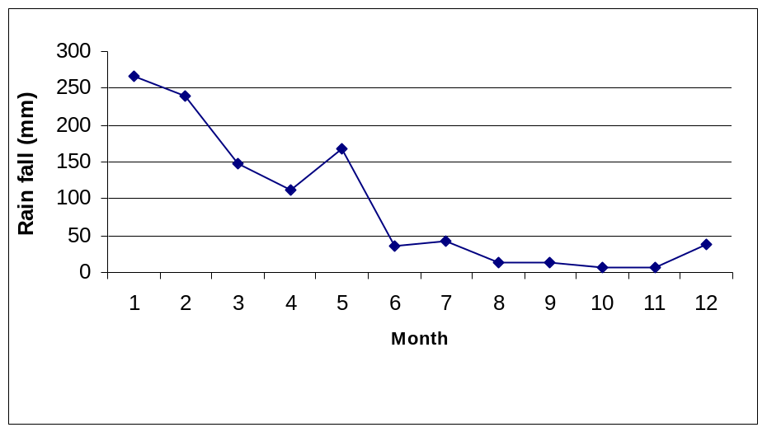
Figure 5: Monthly average rain fall on Aldabra in 2005, all outstations combined.

Total annual precipitation per outstation

In 2005, the outstation with the highest precipitation was Gionnet with 1200 mm. The lowest was Anse var with a value close to 800 mm. In 2005 the rain fall was significantly higher than the average yearly value obtained over the period 1999-2004 for which the maximum value is close to 900 mm and the minimum close to 550 mm (Figure 7).

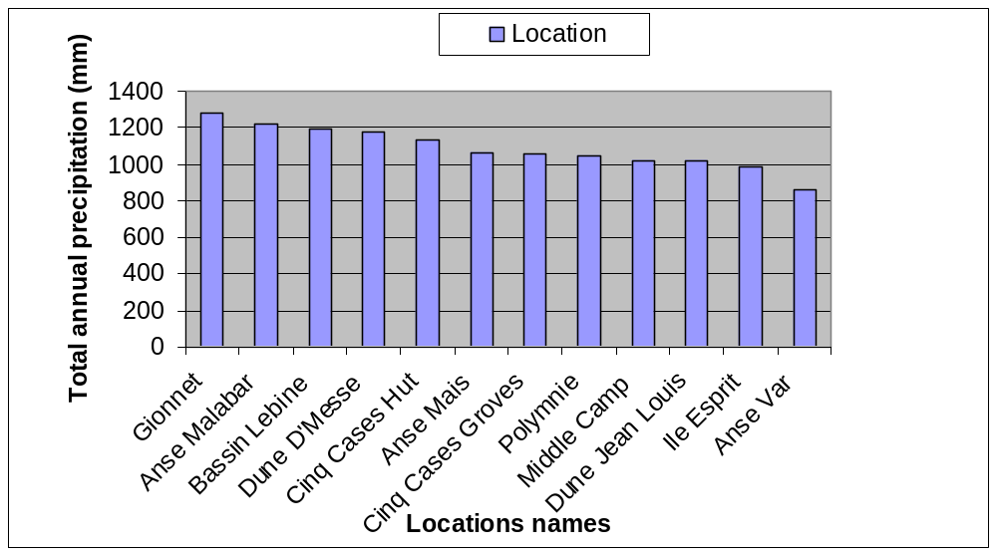
Figure 6: Total annual rain fall at the various outstations on Aldabra in 2005.

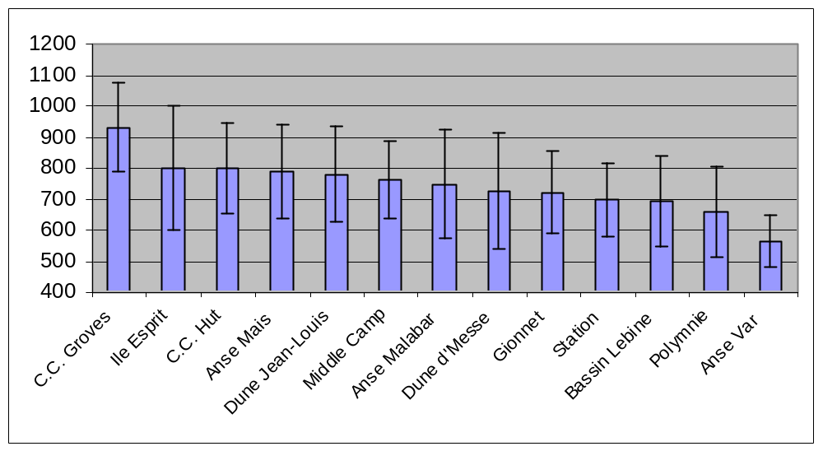

Figure 7: Mean precipitation at the various outstations (1999-2004)
This higher precipitation in 2005 can also be observed from the higher total precipitation value of 1088.1 mm obtained compared with the values of the years 1999-2004. Indeed each other year had values below 1000 mm ( Figure 8).

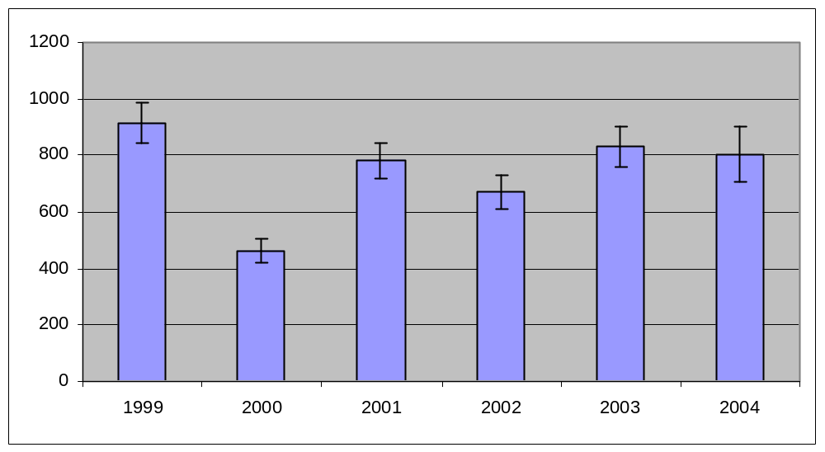
Figure 8 Mean annual precipitation at Aldabra (1999-2004)

Observations made on Precipitation and wind direction (monsoons) in 2005.

In 2005, the first significant rains came in November (research officer reports) while the wind was still blowing from the South east. Only in December some days the wind changed direction, coming clearly form the North West indicating the beginning of the North-west monsoon season. However sometime even the North-west monsoon season, the wind can still blow from the South-east bringing rain with it.

